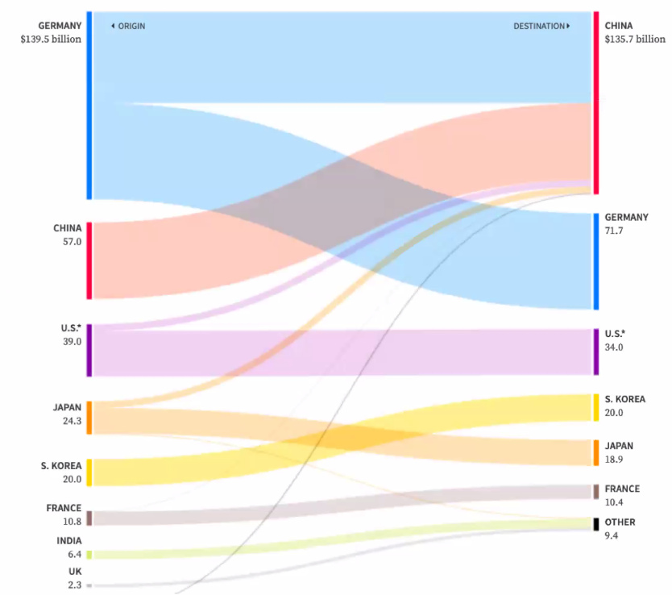

Dataset type:

* + Network GRAPH
* Data types:
  + Links
  + Items
* Attributes:
  + Investment flow (quantitative)
  + Origin Country of automaker (categorical)
  + Destination country (categorical)

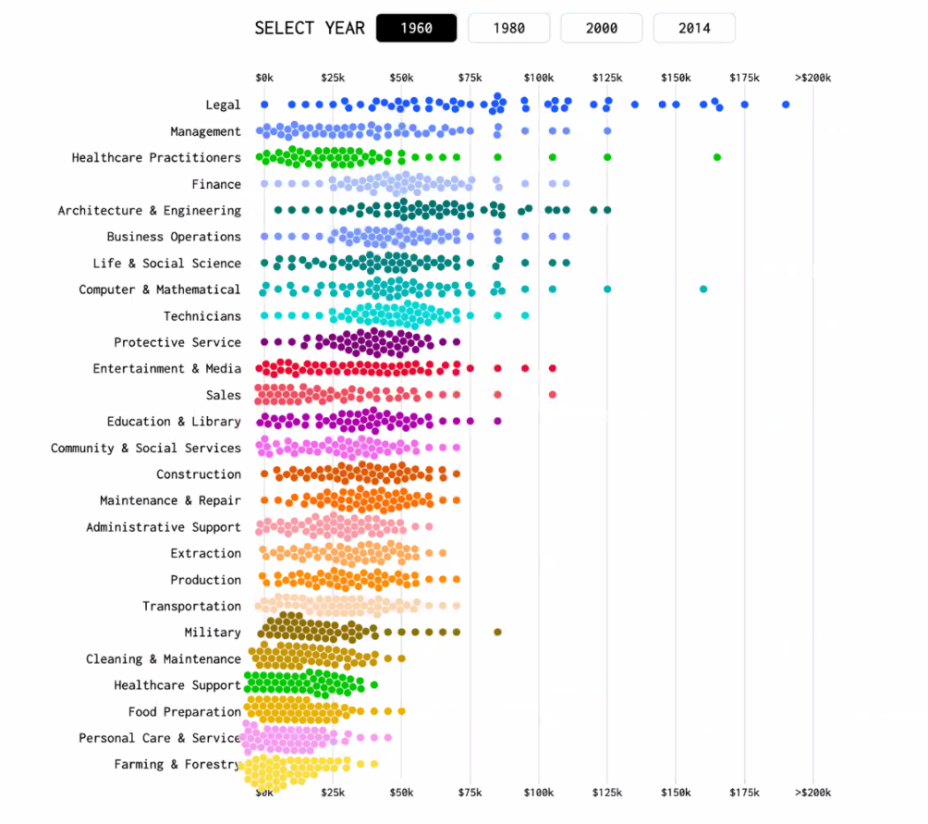

Dataset type:

* Table

Data types:

* Item (Person)
* Attributes

Attributes:

* Occupation (categorical)
* Year (categorical)
* Income (quantitative)